LegalEase
AI-Powered Legal Document Generator
Project Description
Legal document drafting can be time-consuming because users must organize document details, parties, terms, dates, and formal legal language into a structured document. LegalEase addresses this challenge through an AI-powered legal document drafting platform that accepts basic document information and generates a professional draft.
The system uses Google Gemini to generate document content from the selected document type, parties involved, terms and conditions, and effective date. The generated draft can be previewed and edited in the web interface and exported as TXT, DOCX, or PDF. The application combines a browser-based HTML/CSS/JavaScript interface with a FastAPI backend and document-formatting utilities.
Use Case Scenarios
Scenario 1: Agreement Drafting
A user selects an agreement-type document, enters the parties involved, provides the required terms and conditions, and specifies the effective date. LegalEase sends these details to the backend, where the Gemini-powered drafting service generates a structured legal document with a suitable title, parties, date, clauses, and terms.
Scenario 2: Custom Legal Document
When a required document type is not available in the predefined options, the user can select a custom document type and provide the required details. The AI generator uses the supplied information to produce a professional draft without inventing specific personal information.
Scenario 3: Document Editing and Export
After generation, the user can preview and edit the document content. The final draft can be downloaded in supported formats. DOCX export applies professional page margins, Times New Roman formatting, headings, spacing, and a generated-by footer. PDF export provides a formatted legal-document layout with header and page numbering.
Architecture Overview
LegalEase is designed as a modular web application. The frontend collects document information and displays generated content, while the FastAPI backend exposes document-generation and export endpoints. The AI service communicates with Google Gemini to generate the document draft. Utility modules provide document formatting and text sanitization, while automated tests validate health endpoints and document formatters.
Core Technologies
Technology | Purpose
HTML | Web page structure and document-generation interface
CSS | Responsive visual styling, layout, forms, panels, and premium UI design
JavaScript | Frontend interaction, validation, API communication, loading/error states, preview, and downloads
Python | Backend and application logic
FastAPI | REST API and backend routing
Uvicorn | ASGI server used to run the FastAPI application
Google Gemini | AI-powered legal document generation
Pydantic | Request and response data validation
python-docx | DOCX document generation and formatting
FPDF | PDF document generation
python-dotenv | Environment variable and Gemini API-key configuration
Pytest / HTTPX | Automated unit and API testing

Component-Wise Architecture
Component | Description
Frontend UI | Browser-based interface built with HTML, CSS, and JavaScript for document type selection, party details, terms, dates, generation, preview, editing, and export.
Document Builder | Collects document type, parties, terms and conditions, and effective date from the user.
FastAPI Backend | Provides the application API, CORS configuration, health endpoint, generation endpoint, and export endpoints.
Gemini AI Layer | Receives structured document information and generates a professional legal-document draft using Google Gemini.
Document Service | Coordinates the document-generation request and invokes the Gemini document generator.
DOCX Exporter | Creates editable Word documents with page settings, Times New Roman formatting, headings, spacing, and footer.
PDF Exporter | Creates PDF documents with a Unicode-capable font, header, footer, page numbering, headings, bullets, and paragraph formatting.
Security Utility | Sanitizes common typographic characters such as curly quotes and long dashes before further processing.
Testing Layer | Uses Pytest and FastAPI TestClient/HTTPX to test health responses and document formatter outputs.

Pre-requisites
- Python 3.10 or later
- A working internet connection for Gemini API requests and package/model access
- A configured Google Gemini API key
- Required Python packages listed in requirements.txt
- A modern web browser for the HTML/CSS/JavaScript frontend
- Windows TrueType fonts such as Arial, Segoe UI, or Calibri for the current PDF export implementation
Project Workflow
The LegalEase project follows a structured 5-milestone development process, from environment setup to testing and deployment. Each milestone builds the application into a complete AI-assisted legal-document drafting platform.
1. Environment Setup & Configuration
- Set up the LegalEase project directory and backend/frontend organization.
- Create and activate the Python virtual environment.
- Install FastAPI, Uvicorn, Google Gemini, python-docx, FPDF, Pydantic, Pytest, HTTPX, and supporting packages.
- Configure environment variables such as GEMINI_API_KEY and BACKEND_URL.
- Verify backend health and frontend-to-backend connectivity.
2. Core Services Development
- Implement the Gemini document-generation service.
- Create the document service that coordinates AI generation.
- Define Pydantic request and response schemas.
- Implement document formatting utilities for DOCX and PDF.
- Implement text sanitization utilities.
3. Backend Implementation
- Build the FastAPI application and configure CORS.
- Create the document generation endpoint.
- Create DOCX and PDF export endpoints.
- Implement request validation and exception handling.
- Provide root and health endpoints for service verification.
4. UI Development
- Create the LegalEase browser interface using HTML.
- Apply responsive and premium styling using CSS.
- Implement JavaScript controls for document type selection and custom document types.
- Connect the frontend to the FastAPI backend.
- Display generated documents in the editor/preview area.
- Provide document export controls for TXT, DOCX, and PDF.
5. Testing & Optimization
- Test FastAPI root and health endpoints.
- Test HTML preview formatting.
- Test DOCX generation and ZIP signature.
- Test PDF generation and PDF signature.
- Validate input fields and API error handling.
- Optimize document-generation and export workflow for reliable user interaction.
MILESTONE 1: Environment Setup & Configuration
The objective of this foundational stage is to establish the development environment, project structure, dependencies, and API configuration required for LegalEase.
Activity 1.1: Project Structure Setup
Organize the project into frontend, backend, AI core, services, utilities, and tests so that document generation, API routing, formatting, and user-interface code remain modular.
Folder / File | Purpose
frontend/ | HTML, CSS, and JavaScript user interface
backend/main.py | FastAPI application entry point
backend/routes.py | Generation and export API routes
backend/schemas.py | Pydantic request/response models
backend/ai_core/ | Gemini AI integration
backend/services/ | Document-generation service layer
utils/ | Formatting and security utilities
tests/ | Automated tests
requirements.txt | Python dependency list
Dockerfile / docker-compose.yml | Container/deployment configuration
Figure 1: LegalEase AI Project Structure in Visual Studio Code
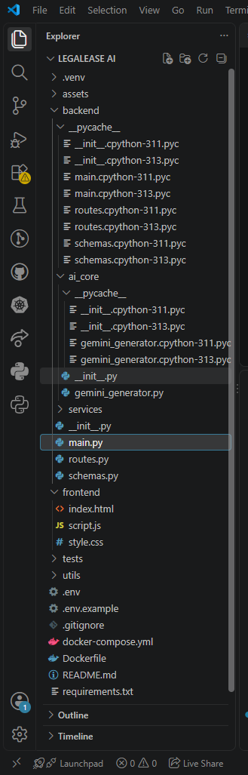
The project is organized into separate backend, AI core, frontend, tests, and utility components. The backend contains the FastAPI application files, routes, schemas, and Gemini integration; the frontend contains index.html, script.js, and style.css; configuration and deployment files include .env, requirements.txt, Dockerfile, and docker-compose.yml.

Activity 1.2: Install Dependencies
Install the packages defined in requirements.txt, including FastAPI, Uvicorn, Streamlit-related project dependencies where present, python-docx, FPDF, Pillow, requests, Google Generative AI support, python-dotenv, Pydantic, Pytest, and HTTPX.
Figure 2: JavaScript Date Handling in the LegalEase Frontend
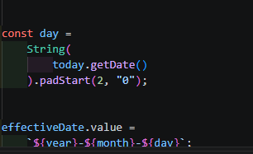
The screenshot shows the frontend JavaScript logic used to obtain the current day, month, and year and format the effective date as YYYY-MM-DD. The day and month values are padded with a leading zero when required, and the resulting date is assigned to the effectiveDate field.
Activity 1.3: Configure Environment Variables
Configure the Gemini API key and backend URL through environment variables. The Gemini generator reads GEMINI_API_KEY and the optional GEMINI_MODEL setting, while the frontend is configured to communicate with the local backend.
Figure 3: LegalEase Frontend HTML Structure
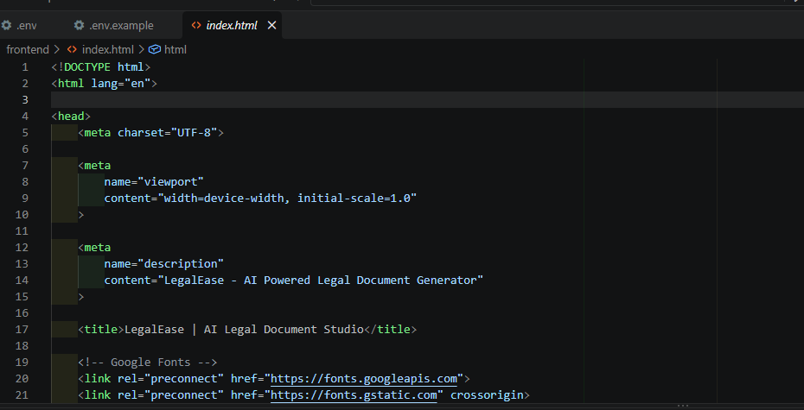
The screenshot shows the index.html file of the LegalEase frontend. It defines the HTML document structure, UTF-8 character encoding, responsive viewport settings, the application description, the LegalEase page title, and external font resource links. This HTML file forms the basic structure of the user-facing LegalEase application.
Activity 1.4: Gemini Setup
- Create or obtain a Google Gemini API key.
- Store the key in the local .env file.
- Ensure the key is not exposed in frontend source code.
- Verify that the selected Gemini model is available to the configured account/API.
- Run the backend and test document generation.
Figure 4: LegalEase AI Frontend User Interface
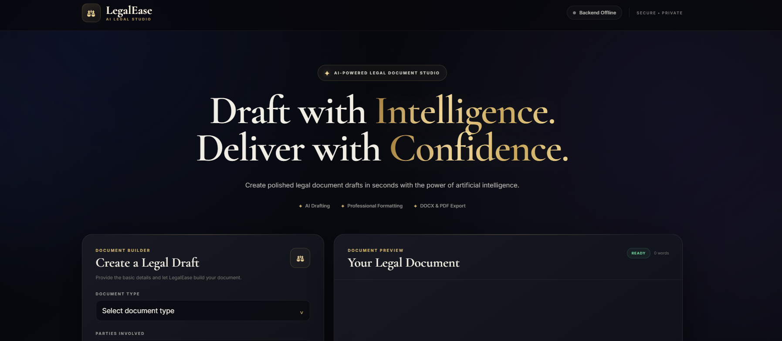
The screenshot shows the completed LegalEase AI frontend interface. It presents the AI-powered legal document studio with the document builder on the left and the document preview area on the right. The interface provides document type selection, document drafting controls, status information, and a professional preview workspace for generated legal documents.
Figure 5: LegalEase Environment Configuration (.env)
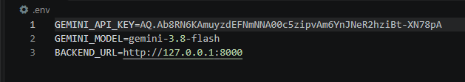
The screenshot shows the LegalEase environment configuration file. It contains the Gemini API key configuration, the selected Gemini model, and the local FastAPI backend URL used by the frontend. These environment settings allow the application to connect the AI generation service and frontend to the local backend without placing the configuration directly in the HTML or JavaScript code.
MILESTONE 2: Core Services Development
This milestone focuses on the AI generation and document-processing services that form the core of LegalEase.
Activity 2.1: Gemini Document Generator Service
Create and use the GeminiDocumentGenerator service to receive the document type, parties, terms, and effective date. The service builds a structured prompt requesting professional legal language, a suitable title, organized terms, and appropriate general clauses while instructing the model not to invent specific personal information.
Activity 2.2: Document Service
The document service provides a modular function that creates the Gemini generator and invokes the document-generation operation. This separates API routing from AI implementation.
Activity 2.3: Request and Response Schemas
The DocumentRequest schema validates document_type, parties, terms, and dates with minimum and maximum length constraints. DocumentResponse returns the generated document content.
Activity 2.4: Document Formatter Service
The formatter utilities provide HTML preview generation, DOCX generation, and PDF generation. DOCX formatting uses Times New Roman, structured headings, margins, spacing, and a footer. PDF formatting provides a title, headers, footers, page numbering, heading detection, bullet handling, and paragraph layout.
Activity 2.5: Security and Text Processing
The security utility sanitizes typographic quotation marks and dash characters into simpler equivalents and trims the final text. This supports consistent downstream document processing.
MILESTONE 3: Backend Implementation
This milestone integrates the services into a FastAPI backend with API routes, validation, export operations, CORS support, and error handling.
Figure 6: LegalEase Frontend HTML Implementation
The screenshot shows the LegalEase frontend HTML implementation in index.html. The page defines the document structure, responsive viewport configuration, application description, page title, and external font resources. This frontend layer provides the foundation for the LegalEase user interface and connects the presentation layer with the backend document-generation workflow.
Activity 3.1: FastAPI Application
The main application creates the LegalEase API, configures CORS, includes the application router, and provides root and health endpoints for service verification.
Activity 3.2: Document Generation Endpoint
The POST /generate endpoint accepts a validated DocumentRequest and returns the generated legal document. Exceptions are converted into HTTP 500 responses with the error detail.
Activity 3.3: DOCX Export Endpoint
The POST /export/docx endpoint receives document content and creates an editable Word file in memory. It applies one-inch margins, Times New Roman formatting, title styling, paragraph spacing, heading detection, and a generated-by footer.
Activity 3.4: PDF Export Endpoint
The POST /export/pdf endpoint generates a PDF in memory. The implementation searches common Windows font locations, creates a Unicode-capable PDF, formats headings and bullets, and adds header/footer information including page numbers.
MILESTONE 4: UI Development
The LegalEase frontend provides the user-facing document builder and connects it to the FastAPI backend.
Activity 4.1: Main Layout Design
- Create a professional LegalEase navigation/header area.
- Provide a document-builder form.
- Provide fields for document type, parties, terms, and effective date.
- Provide a generated-document editor/preview area.
- Provide export controls.
- Display system status, loading state, and error messages.
Figure 7: LegalEase Document Builder and Document Preview Interface
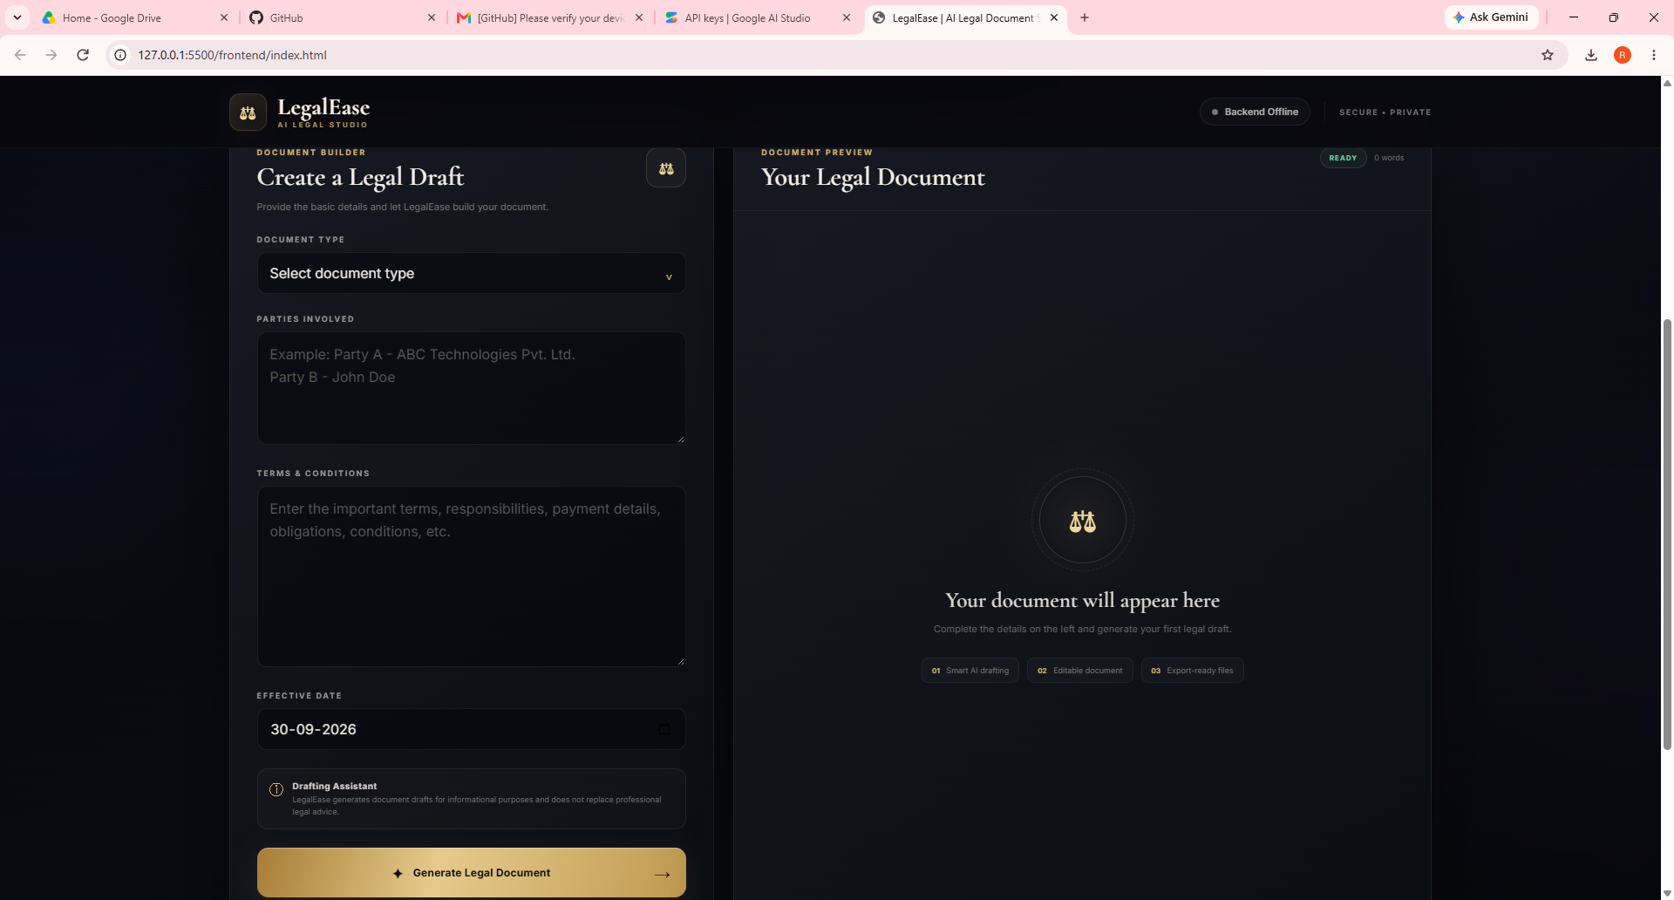
The screenshot shows the LegalEase main web interface running in a browser. The layout is divided into two main sections: the Document Builder on the left and the Document Preview on the right. The builder provides document type selection, party details, terms and conditions, effective date, and a Generate Legal Document button. The preview area displays the generated document and its current status. The interface also includes the LegalEase branding, backend status indicator, and drafting-assistant notice.
Activity 4.2: Document Type Controls
- Allow selection of predefined document types.
- Display a custom document-type field when Other is selected.
- Clear the custom type when a predefined type is selected.
- Validate required information before generation.
Figure 8: LegalEase – Document Type and Input Details
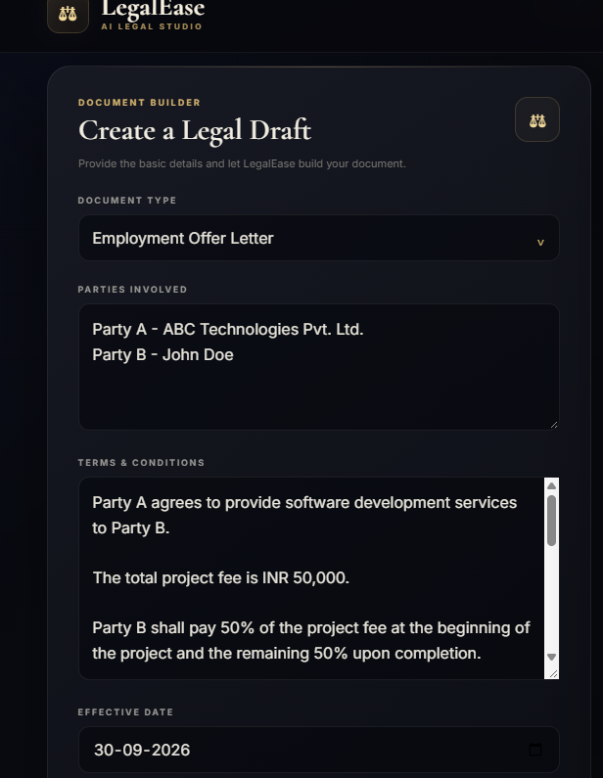
The screenshot shows the LegalEase document type control and the populated input fields. The selected document type is Employment Offer Letter. The parties are entered as ABC Technologies Pvt. Ltd. and John Doe, while the terms and conditions contain the project fee and payment details. The effective date is set to 30-09-2026. These inputs are used as the source information for generating the legal document.
Activity 4.3: Results Display
- Show the generated legal document in the editor.
- Provide document status and word-count information.
- Allow users to edit the generated content before export.
- Display errors clearly when backend generation fails.
Activity 4.4: Export Functionality
- Provide TXT download functionality.
- Send content to the DOCX export endpoint.
- Send content to the PDF export endpoint.
- Use suitable file names for generated legal documents.
MILESTONE 5: Testing & Optimization
Testing ensures that the LegalEase backend and document-generation utilities behave correctly and that generated files have the expected formats.
Activity 5.1: Unit Testing
- Test HTML preview formatting and paragraph creation.
- Test DOCX generation and verify the returned file has a valid DOCX ZIP signature.
- Test PDF generation and verify the returned content starts with the PDF signature.
- Test individual document formatting utilities.
Activity 5.2: Integration Testing
- Test the complete flow from document request to AI-generated document.
- Test the FastAPI root endpoint.
- Test the health endpoint.
- Test export endpoints with generated or sample content.
- Validate frontend/backend communication and error handling.
Activity 5.3: Performance and Reliability Optimization
- Keep AI generation separate from formatting and routing logic.
- Generate export files in memory to avoid unnecessary temporary-file handling.
- Validate request sizes before sending data to the AI service.
- Provide clear frontend loading and error states.
- Use modular services so individual components can be tested and improved independently.
Expected Application Operations
Operation | Expected Result
Backend startup | FastAPI service becomes available through Uvicorn
Health check | Returns a healthy status response
Document generation | Returns AI-generated legal document content
Frontend preview | Displays generated content for review/editing
TXT export | Downloads document text
DOCX export | Downloads editable Word document
PDF export | Downloads formatted PDF document

Deployment Guide
Option 1: Local Deployment
- Open PowerShell in the LegalEase project directory.
- Activate the Python virtual environment.
- Install dependencies using pip install -r requirements.txt.
- Configure the GEMINI_API_KEY in .env.
- Start the backend with: python -m uvicorn backend.main:app --host 127.0.0.1 --port 8000.
- Open the frontend HTML file through a local web server or the configured frontend environment.
- Verify the backend health endpoint before generating documents.
Option 2: Docker Deployment
The project includes a Dockerfile and docker-compose.yml intended to provide containerized backend/frontend services. Before production deployment, the compose commands and frontend entry point should be checked against the current project files because the repository contains both a browser-based frontend and deployment configuration referring to a Streamlit frontend.
Troubleshooting Guide
Issue | Recommended Check
Gemini API error | Check GEMINI_API_KEY, model configuration, internet connection, and API availability.
Uvicorn command not recognized | Use python -m uvicorn after activating the virtual environment and installing requirements.
Backend not reachable | Verify that FastAPI is running on 127.0.0.1:8000 and that the frontend BACKEND_URL matches it.
PDF export fails | Check that a supported Windows TrueType font exists at one of the configured paths.
DOCX export fails | Verify python-docx is installed and that the export request contains valid content.
Invalid request | Check document type, parties, terms, and dates against the Pydantic length constraints.
Frontend generation error | Check browser developer-console errors and confirm the backend API is running.

Conclusion
LegalEase provides an AI-assisted workflow for creating structured legal document drafts from basic user-provided information. The application combines a browser-based interface, FastAPI services, Google Gemini generation, and document-export utilities to reduce the manual effort involved in preparing initial legal drafts.
The modular architecture separates user interaction, API routing, AI generation, document services, formatting, security utilities, and testing. This structure makes the project easier to maintain and extend while allowing users to review and edit generated content before exporting it.
Future Enhancements
- Support additional legal document templates and document types.
- Add multilingual document generation.
- Add user accounts and document history.
- Add secure document storage and retrieval.
- Add stronger role-based access control.
- Add template customization and organization-specific clauses.
- Add document comparison and revision tracking.
- Add cloud deployment and scalable AI service management.
- Add richer PDF/DOCX formatting and digital-signature workflows.
- Add audit logging and improved privacy controls.
- Add configurable AI model selection and generation settings.

